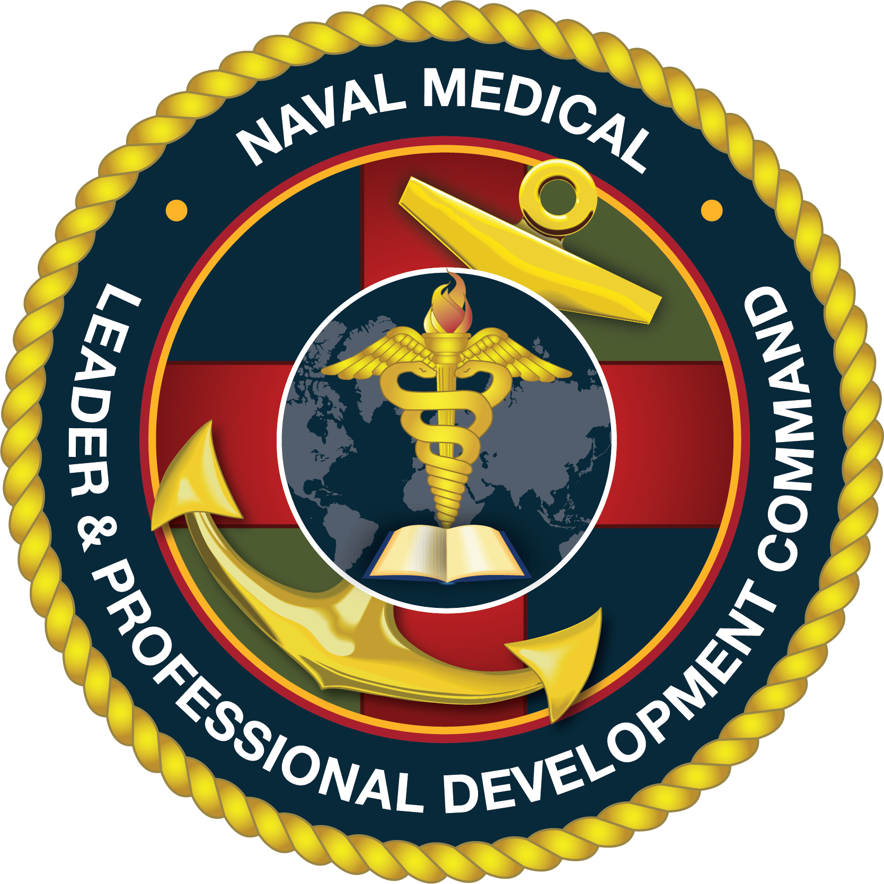 NAVAL MEDICAL
LEADER & PROFESSIONAL DEVELOPMENT COMMAND
COURSE INFORMATION
Quick Reference – FY22 Course Dates – 1st Ed.
As of 27 Oct 2021
Advanced Readiness Officers Course (AROC)
Course Title | Course Number | Course Start Date | Course End Date |  | Nom Due Date
A-ROC | 22-10 | 18-Oct-21 | 29-Oct-21 |  | 06-Sep-21
A-ROC | 22-20 | 10-Jan-22 | 21-Jan-22 |  | 01-Dec-21
A-ROC | 22-30 | 14-Feb-22 | 25-Feb-22 |  | 27-Dec-21
A-ROC | 22-40 | 14-Mar-22 | 25-Mar-22 |  | 24-Jan-22
A-ROC | 22-50 | 18-Apr-22 | 29-Apr-22 |  | 01Mar-22
A-ROC | 22-60 | 13-Jun-22 | 24-Jun-22 |  | 25-Apr-22
A-ROC | 22-70 | 18-Jul-22 | 29-Jul-22 |  | 30-May-22
A-ROC | 22-80 | 15-Aug-22 | 26-Aug-22 |  | 27-Jun-22
A-ROC | 22-90 | 12-Sep-22 | 23-Sep-22 |  | 01-Aug-22
Clinic Management Course (CMC)
Course Title | Course Number/Location | Course Start Date | Course End Date |  | Nom Due Date
CLINIC MGMT | 22-10 / NH Charleston | ​16-Nov-21 | 19-Nov-21 |  | 17-Sep-21
CLINIC MGMT | 22-20 / USNH Okinawa | 14-Dec-21 | 17-Dec-21 |  | 15-Oct-21
CLINIC MGMT | 22-30 / NHC Hawaii | 11-Jan-22 | 14-Jan-22 |  | 12-Nov-21
CLINIC MGMT | 22-40 / NH Jacksonville | 08-Feb-22 | 11-Feb-22 |  | 17-Dec-21
CLINIC MGMT | ​22-50 / NMC San Diego | 22-Mar-22 | 25-Mar-22 |  | 21-Jan-22
CLINIC MGMT | 22-60 / NH Pendleton | 12-Apr-22 | 15-Apr-22 |  | 18-Feb-22
CLINIC MGMT | 22-70 / NMC Portsmouth | 10-May-22 | 13-May-22 |  | 11-Mar-22
CLINIC MGMT | 22-80 / Mid-Atlantic Navy Clinics (Bethesda) | 14-Jun-22 | 17-Jun-22 |  | 08-Apr-22
CLINIC MGMT | ​22-90 / USNH Rota | 12-Jul-22 | 15-Jul-22 |  | 13-May-22
CLINIC MGMT | 22-100 / NH Bremerton | 10-Aug-22 | 13-Aug-22 |  | 10-Jun-22
CLINIC MGMT | Faculty Conference (Bethesda) | 30-Aug-22 | 02-Sep-22 |  | N/A
Financial & Materiel Management Training Course (FMMTC)
Course Title | Course Number | Course Start Date | Course End Date |  | Nom Due Date
FMMTC | 22-10 | 31-Jan-22 | 08-Apr-22 |  | 17-Dec-21
FMMTC | 22-20 | 11-Jul-22 | 16-Sep-22 |  | 20-May-22
Military Tropical Medicine (MTM)
Course Title | Course Number | Course Start Date |  | Course End Date | Nom Due Date
MTM-DIDACTIC | 22-10 | 05-Jul-22 |  | 29-Jul-22 | 02-Mar-22
MTM-VIRTUAL | 22-10 | 05-Jul-22 |  | 31-Mar-23 | Rolling 31 Dec-21
MTM-FIELD | 22-10 | 29-Jul-22 |  | 12-Aug-22 | 02-Mar-22
NAVAL MEDICAL
PROFESSIONAL & DEVELOPMENT COMMAND
COURSE INFORMATION
Quick Reference – FY22 Course Dates – 1st Ed.
As of 27 Oct 2021
Executive Medical Department Enlisted Course (EMDEC)
Course Title | Course Number | Course Start Date |  | Course End Date | Nom Due Date
EMDEC | 22-10 | 06-Dec-21 |  | 17-Dec-21 | 04-Oct-21
EMDEC | 22-20 | 31-Jan-22 |  | 11-Feb-22 | 29-Nov-21
EMDEC | 22-30 | 28-Feb-22 |  | 11-Mar-22 | 27-Dec-21
EMDEC | 22-40 | 04-Apr-22 |  | 16-Apr-22 | 31-Jan-22
EMDEC | 22-50 | 30-May-22 |  | 10-Jun-22 | 28-Mar-22
EMDEC | 22-60 | 06-Jul-22 |  | 15-Jul-22 | 09-May-22
Patient Administration Course (PAC)
Course Title | Course Number | Course Start Date | Course End Date |  | Nom Due Date
PAC | 22-10 | 24-Jan-22 | 18-Feb-22 |  | 03-Dec-21
PAC | 22-20 | 18-Apr-22 | 13-May-22 |  | 25-Feb-22
PAC | 22-30 | 06-Jun-22 | 01-Jul-22 |  | 06-May-22
Plans, Operations, and Medical Intelligence Course (POMIC)
Course Title | Course Number | Course Start Date | Course End Date |  | Nom Due Date
POMI | 22-10 | 18-Oct-21 | 5-Nov-21 |  | 20-Aug-21
POMI | 22-20 | 28-Feb-22 | 18-Mar-22 |  | 07-Jan-22
POMI | 22-30 | 16-May-22 | 03-Jun-22 |  | 18-Mar-22
POMI | 22-40 | 18-Jul-22​ | 05-Aug-22 |  | 20-May-22
Tricare Financial Management Executive Program (TFMEP)
Course Title | Course Number/Location | Course Start Date | Course End Date |  | Nom Due Date
TFMEP | 22-10/USNH Portsmouth, VA | 09-Feb-22 | 11-Feb-22 |  | 17-Dec-21
TFMEP | 22-20/Bethesda, MD | 11-May-22 | 13-May-22 |  | 25-Mar-22
TFMEP | 22-30/San Diego, CA | 08-Jun-22 | 10-Jun-22 |  | 08-Apr-22
TFMEP | 22-40/Hawaii | 09-Nov-22 | 11-Nov-22 |  | 09-Sep-22
Navy Medicine 101 Course (NM 101)
Course Title | Course Number/Location | Course Start Date | Course End Date |  | Nom Due Date
NM-101 | 22-10 | 01-Nov-21 | 05-Nov-21 |  | 24-Sep-21
NM-101 | 22-20 | 21-Nov-21 | 24-Nov-21 |  | 15-Oct-21
NM-101 | 22-30 | 28-Feb-22 | 04-Mar-22 |  | 21-Jan-22
NM-101 | 22-40 | 04-Apr-22 | 08-Apr-22 |  | 25-Feb-22
NM-101 | 22-50 | 09-May-22 | 13-May-22 |  | 01-Apr-22
NM-101 | 22-60 | 13-Jun-22 | 17-Jun-22 |  | 06-May-22
NM-101 | 22-70 | 18-Jul-22 | 22-Jul-22 |  | 10-Jun-22
NM-101 | 22-80 | 29-Aug-22 | 02-Sep-22 |  | 22-Jul-22

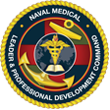 NAVAL MEDICAL
LEADER & PROFESSIONAL DEVELOPMENT COMMAND
COURSE INFORMATION
Quick Reference – FY21 Course Dates – 3rd Ed.
As of 27 Oct 2021
Oral Maxillofacial "C" School, Bethesda, Maryland
Course Title | Course Number/Location | Course Start Date | Course End Date | Quotas
HM-MAXILLO L38A | B-331-0018/Bethesda, MD | 03-Jan-22 | 22-Jun-22 | 2
HM-MAXILLO L38A | B-331-0018/Bethesda, MD | 27-Jun-22 | 16-Dec-22 | 2
Hemodialysis Technician "C" School, Portsmouth, Virginia
Course Title | Course Number/Location | Course Start Date | Course End Date | Quotas
HM-DIALYSIS L13A | B-311-0123/Portsmouth, VA | 06-Jan-22 | 15-Apr-22 | 2
HM-DIALYSIS L13A | B-311-0123/Portsmouth, VA | 05-May-22 | 12-Aug-22 | 2

